Beyond Access: SEL-Informed Instruction and Student Learning in Middle School Mathematics

Qua’lani Ferguson
April 2026

Abstract
This practitioner research study examines the relationship between social-emotional learning (SEL)-informed instruction and students’ short-term mathematical understanding in a middle school classroom. While prior research demonstrates that SEL positively influences student outcomes, much of the literature focuses on individual-level measures rather than what is happening inside classrooms during instruction. This study addresses that gap by comparing student performance under two instructional conditions: a traditional math lesson structure and an SEL-informed lesson structure emphasizing discourse, productive struggle, and supportive feedback. Data was collected from 25 seventh-grade students using aligned exit tickets measuring conceptual understanding. Descriptive statistics, including means and standard deviations, were used to compare performance across conditions. Findings suggest that SEL-informed instruction is associated with higher average scores and more consistent student performance. These results reinforce the idea that how students learn is just as important as what they learn, particularly in mathematics.

Introduction and Literature Review
In middle school mathematics classrooms, student success is often defined by correctness, speed, and performance on assessments. However, this narrow framing overlooks a critical reality: learning is deeply influenced by students’ social and emotional experiences. Students’ willingness to take risks, share their thinking, and persist through difficulty is shaped not only by their academic ability but also by how safe and supported they feel in the classroom.
Social-emotional learning (SEL) has emerged as a key framework for supporting student development. Research shows that SEL programs are associated with improvements in academic achievement, behavior, and student attitudes (Collaborative for Academic, Social, and Emotional Learning [CASEL], 2020). However, a major limitation in this research is that SEL is often implemented at the classroom level but evaluated using outcomes that do not fully capture classroom dynamics (Jones et al., 2017). As a result, we know SEL “works,” but we know far less about how it works during instruction.
Research on classroom quality provides a useful bridge. Studies have found that emotionally supportive classrooms, those where students feel respected, encouraged, and safe to engage, are associated with higher levels of student learning (Hamre et al., 2014). These findings suggest that SEL may influence academic outcomes through everyday instructional practices, such as teacher feedback, classroom norms, and opportunities for discourse.
This is especially relevant in mathematics, a subject where students often experience anxiety, fear of being wrong, and disengagement. Traditional math instruction can unintentionally reinforce these feelings by prioritizing speed and correctness over sense making. For students from historically marginalized backgrounds, these dynamics can further limit participation and access to learning.
This study builds on existing research by examining SEL not as a separate program, but as something embedded within instruction. By focusing on classroom level practices, this research aims to better understand how teaching moves influence student learning in real time.

Research Question
This study is guided by the following research question:
To what extent is SEL-informed math instruction, relative to a traditional lesson structure, associated with students’ short-term understanding of a new mathematical concept?
This question builds on existing literature by shifting the focus from broad outcomes to what is happening within the classroom during instruction. Rather than attempting to establish causation, this study examines the relationship between instructional approach and student performance in a real classroom setting.
Based on both prior research and classroom experience, it is expected that students will perform better under the SEL informed condition. This is because instructional practices that emphasize discourse, collaboration, and productive struggle are more likely to support conceptual understanding than those focused primarily on procedures.

Setting and Intervention
This study was conducted in one seventh grade mathematics classroom in an urban public charter school serving a diverse student population. The class consists of 25 students, many of who are from historically marginalized backgrounds, including students eligible for free or reduced lunch and English language learners. These demographics make this setting particularly relevant for examining equitable instructional practices.
Two instructional conditions were compared:
Traditional Instruction:
This approach followed a more conventional structure, including direct instruction, guided practice, and independent work. Teacher discourse focused on correct answers and procedures, with limited opportunities for student discussion or explanation.
SEL Informed Instruction:
This approach intentionally integrated SEL practices into instruction. Students engaged in structured discourse, explained their reasoning, and collaborated with peers. Teacher language emphasized growth, effort, and sense-making, and students were encouraged to view mistakes as part of the learning process.
Both lessons were aligned to similar content and difficulty levels to ensure a fair comparison between conditions.

Data Sources and Sample
Data was collected from all 25 students in the classroom using two aligned exit tickets administered after each instructional condition. This resulted in a 100% response rate, as all students present completed the assessments.
Each exit ticket included 3–5 questions designed to assess conceptual understanding of the lesson objective. Scores were converted into percentages to allow for comparison across conditions.
Variables:
- Independent Variable: Instructional condition (traditional vs. SEL-informed)
- Dependent Variable: Exit ticket score (percentage correct)
A score of 70% or higher was considered proficient based on classroom expectations, providing a clear benchmark for interpreting student performance.

Analytic Method
Data was analyzed using descriptive statistics in Microsoft Excel. Mean scores and standard deviations were calculated for each instructional condition to examine both overall performance and variation in student outcomes.
This approach was selected because it allows for a clear comparison between conditions while remaining appropriate for a small sample size. By focusing on patterns in the data, this analysis provides insight into how instructional practices may be associated with differences in student understanding.

Findings

Table 1
Exit Ticket Performance by Instructional Condition
Condition | Mean (%) | Standard Deviation
Traditional | 68 | 15
SEL-Informed | 75 | 10
Students demonstrated higher average performance under the SEL informed condition. In addition, the lower standard deviation suggests that student outcomes were more consistent, indicating that fewer students struggled significantly.
This pattern suggests that SEL informed instruction may not only improve overall performance but also reduce variability in student outcomes, which is particularly important in promoting equity in the classroom.

Figure 1
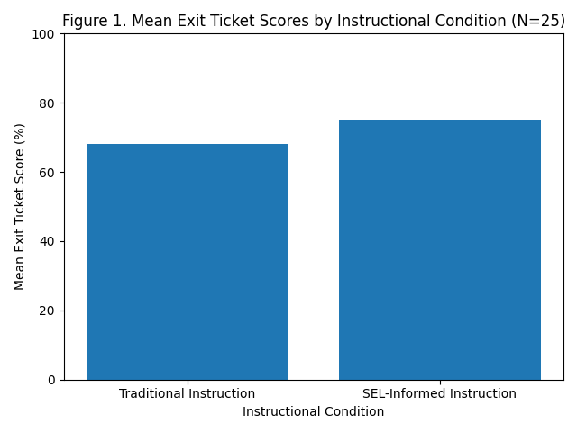
Figure 1. Mean Exit Ticket Scores by Instructional Condition (N = 25)

Discussion and Conclusion
The findings from this study suggest that SEL informed instructional practices are associated with improved student performance in middle school mathematics. Students not only performed better on average, but their outcomes were more consistent, suggesting that this approach may better support a wider range of learners.
These results align with existing research indicating that classroom climate and instructional quality influence student learning (Hamre et al., 2014). By embedding SEL into instruction, teachers can create environments where students feel more comfortable engaging, taking risks, and making sense of mathematical ideas.
However, this study has several limitations. The small sample size and single classroom setting limit the generalizability of the findings. Additionally, the lack of random assignment introduces potential confounding variables, such as differences in student motivation or prior knowledge. It is also possible that subtle differences in lesson content influenced outcomes.
Despite these limitations, the study offers meaningful implications for practice. It suggests that integrating SEL into everyday instruction is not just beneficial for classroom culture, but also for academic outcomes. Rather than treating SEL as an add on, educators should consider it a core component of effective teaching.
Future research could expand on this work by including larger samples, multiple classrooms, and additional measures of student experience. Even so, this study reinforces a key idea: students learn best in environments where they feel supported, challenged, and valued.

References

Collaborative for Academic, Social, and Emotional Learning (CASEL). (2020). What is SEL? https://casel.org
Hamre, B. K., Pianta, R. C., Mashburn, A. J., & Downer, J. T. (2014). Building a science of classrooms: Application of the CLASS framework. American Educational Research Journal, 51(4), 753–791.
Jones, S. M., Bailey, R., Brush, K., & Nelson, B. (2017). The evidence base for how we learn: Supporting students’ social, emotional, and academic development. Harvard Graduate School of Education.

AI Declaration
AI tools were used to support organization and visuals. All analysis, interpretation, and written content reflect my original work.

